GCH Fostering Application Form

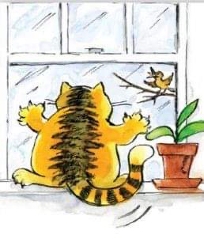
Have you ever considered fostering a junior or adult cat? Sometimes at GCH there are cats who need emergency, short-term or long-term fostering, before they are either returned to their owners or are put up for adoption. If you live within 5 miles of Voo Vets at Worcester Park or Surbiton, have access to a car, work mostly from home and have no children under 8 and no dogs, you may be the person for us. We would like to have a register of reliable fosterers whom we can call upon if the need arises. This may be at short notice!

Fosterers need to have cat experience, and preferably a spare room for the cat to have its own space. We would expect fostered cats to remain indoors. GCH will pay for food, litter and any medical treatment, also a pen if required.

We shall need to know some background details about you, so we can see what sort of fostering might be best for you. We would like to see a photo or video of the cat’s room’ as well please! We would then like to meet you in person to see that we can work well together.

If you are interested, please fill in the form below and email it to us at Team@gingercathouserescue.co.uk and attach some photos of your living space. Even if you are already home checked for adoption and on the cat or kitten list, we would ask you to fill in this form separately*.

PERSONAL INFORMATION:

Full name:

Full address including post code:
If renting, do you have landlord’s permission for pets?:
Contact number:
Email address:

HOUSEHOLD DETAILS
Details of your household (including ages of any children):

Details of any pets (ages, description and experience with cats):

If you are employed, please give details of your usual working pattern (working from home, part-time etc), as this may impact which cats we can send to you:

Do you have a spare room for the cat(s) to have their own space?
Have you attached photos of your living space with this application?
FOSTERING INFORMATION
Please give details of your experience looking after cats:

What type of fostering are you interested in? | Emergency (short notice, a few days)
 | Short-term (up to 3 months)
 | Long-term (up to 6 months)
Do you wish to foster | Adult cats only
 | Junior cats only (6 months – 2 years)
 | No preference
Would you be prepared to foster more than one cat at a time?
Would you be prepared to foster cats with medical issues?

If YES, please give details of your medical experience:

Would you be able to start immediately? If not, please let us know from when.

Please note you will need transport to use our vets: VOO VETS, The Parade, 5 Vale Road, Worcester Park KT4 7EE or the Hospital at 30 Claremont Road, Surbiton KT6 4RF, as we shall be paying any vet bills. Please factor the time it would take you to get there into your decision to apply to foster with us.

*The information in this form is confidential and will only be used for the purpose of internal record keeping and communication with you. No information will be shared with any third parties. All data will be deleted after 6 months, or when you have ceased fostering with us.

Signed:

Date:

