GCH Adoption Application Form

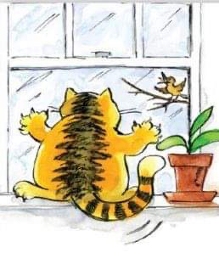
If you wish to adopt an adult cat, please fill out this for a home check, and email it to us on adoptions@gingercathouserescue.co.uk.
Applicants for adult cats will go on a waiting list. Once home checked, when cats appear on the website, please apply to be shortlisted. All cats will be neutered, chipped and vet checked before they leave us.

Kittens will be posted on our website when they are ready for adoption. Then you will have 4 days to apply for a home check via this form so that you can be shortlisted. There is no waiting list. Please only apply for kittens which are the colour, sex and age you would like. All kittens will be vet checked and have had their first vaccination before they leave us.

We shall match cats or kittens to the best home from the shortlists. You will need to live within 100 miles of the rescue in Worcester Park to be considered, so please take this into account before applying for a home check. If applying for an outdoor cat, please note you will not be considered if you live near a main road.

PERSONAL INFORMATION:

Full name:
Full address including post code:

Contact number:
Email address:
Age group: | 18-29
 | 30-44
 | 45-59
 | 60-69
 | 70-79
Type of Property
Owned house/ flat
Rented house/ flat with landlord’s permission
Sheltered accommodation with permission
HOUSEHOLD DETAILS
Details of your household (including ages of any children):

Details of any pets (ages, description and experience with cats):

If you have other cats, are they | Chipped
 | Neutered
 | Insured
If you are employed, please give details of your usual working pattern (working from home, part-time etc), as this may impact which cats we can send to you:

What type of building do you live in (detached house, first floor flat etc)?
Do you have a secure garden (for outdoor cat) or secure balcony (indoor cat)?
Do you live near a main or busy road?
Have you sent photos of your living space and garden with this application?
ADOPTION INFORMATION
Please give details of your experience looking after cats:

What age cat are you looking for? | Kitten (up to 6 months)
 | Junior (6 mths – 1 year)
 | Adult (1-7)
 | Senior (7+)
 | No preference
Do you wish to adopt | Male
 | Female
 | No preference
What type of cat are you looking for? | Indoor
 | Outdoor
 | No preference
Do you have any colour preferences?

Would you like to adopt a pair of cats or kittens?
Would you be prepared to adopt cats or kittens with medical issues?
If YES, please give details of your medical experience:

ADDITIONAL INFORMATION: please use the space below for any further information which may help your application e.g. a recommendation from a vet or regular follower. NB. This is not essential.

*The information in this form is confidential and will only be used for the purpose of internal record keeping and communication with you. No information will be shared with any third parties. All data will be deleted after 6 months, or when you have ceased fostering with us.

Signed:

Date:

